**Practical -2**

**Title**

Create version control account on GitHub and using Git commands to create repository and push your code to GitHub.

**Objective**

1. Understand how to the create an account on Github
2. Using Git commands to create repository and push code to Github.

**Platform**

Github

**Theory**

**Github:**

GitHub is a code hosting platform for version control and collaboration. GitHub is an online software development platform used for storing, tracking, and collaborating on software projects.

 It is a web-based interface that uses [Git](https://git-scm.com/), the open source version control software that lets multiple people make separate changes to web pages at the same time. Because it allows for real-time collaboration, GitHub encourages teams to work together to build and edit their site content.

**Downloading and installing GitHub Desktop**

**Step1-** Visit the download page for GitHub Desktop.

**Step2**- Click Download for Windows8

**Step3-** In your computer's Downloads folder, double-click the GitHub Desktop zip file.

**Step 4**- After the file has been unzipped, double-click GitHub Desktop.

**Step5**- GitHub Desktop will launch after installation is complete.

**How Do I Repo a Project on GitHub?**

How files are changed and merged in GitHub. This can be done by any member on the team, developers and non-developers,that has access to a GitHub repository. The following is a step-by-step method in which GitHub users can develop their websites:

**Step 1** — Team members will open an issue via a project board.

**Step 2** — Team members will create a new branch from the most recent version of the main branch in the repository where the entire team works to avoid conflicts.

**Step 3** — Team members will add commits (edits/ changes) to their respective branches.

**Step 4** — Team members will open a pull request in which users can assign other team members to review content changes and internally discuss the details of the commits.

**Step 5** — After waiting for the Federalist build to complete, team members can preview the change on a test version of the website and request reviewers to approve or comment on the change. Once the reviewers approve the pull request, the commits merge into the main branch and are published on the live site.

**Implementation**

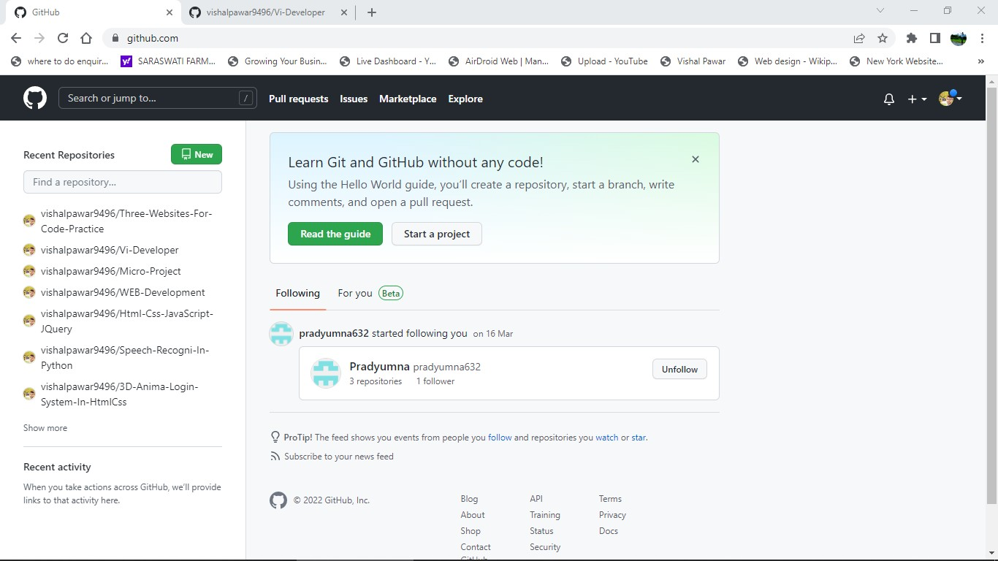



g visnalpawar9496 / Vi-Developer ^•!'•

cv co fiie Aad rim - About 

@ e6sesae on 13 Ma r 4 commils

*No description. website. or topics provided.*

  



Vi-Developer

## Web Search A

Add fi Yes via upI oad



@ visnalpawar9496 / Vi-Developer '""° 





Add fi Yes via upload

Go to file Add liii - About

@ e6s esze on 13 Mar 4 comm us

Your codespaces



## Upgrade



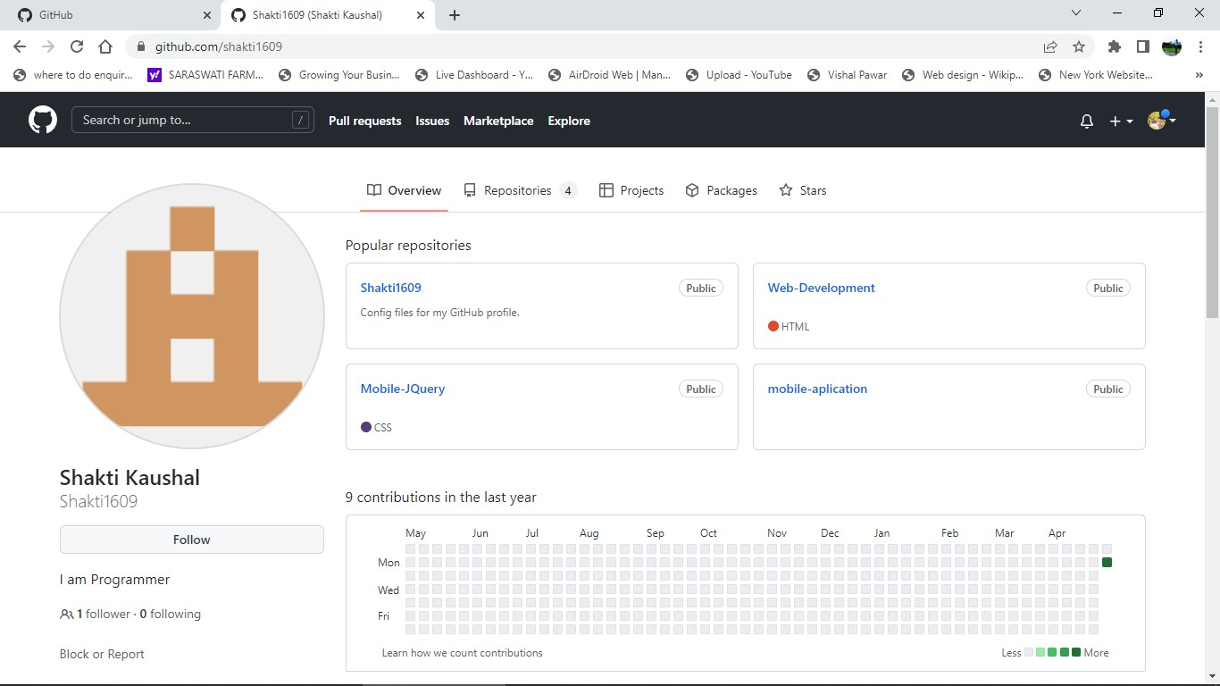

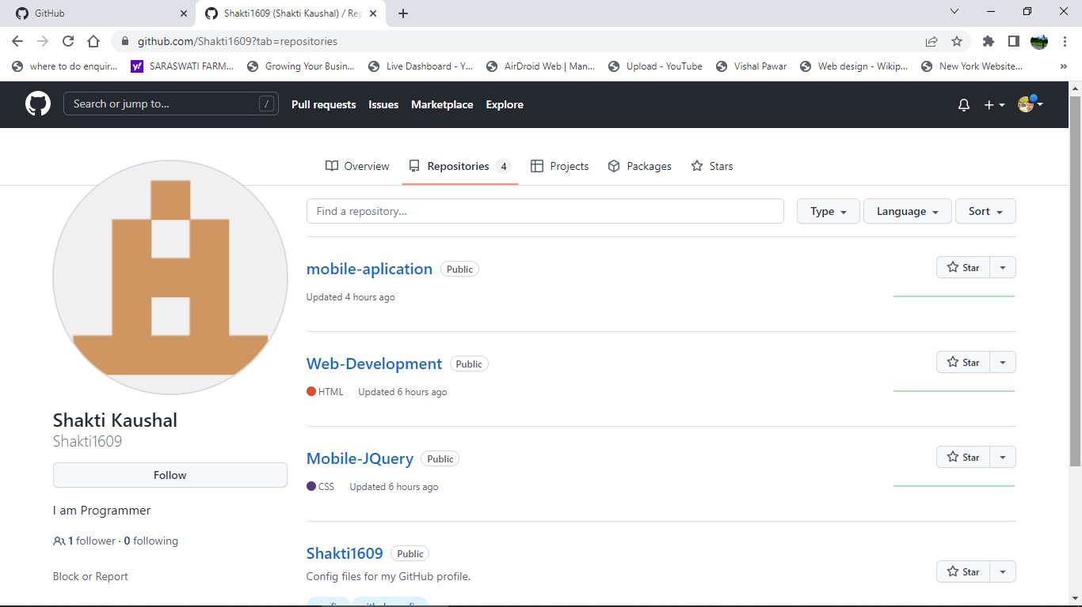

**Conclusion:**

With the help of this assignment it is helpful to understand how to create github account and repo and push the code in github account.